MEDIA INFORMATION | June 2023
BSSE Research Building Schällemätteli, Basel

Research takes over former prison area

A new life sciences campus is being built in Basel. The ambitious goal is to be at the forefront of the world’s most important research locations for life sciences. ETH Zurich is also part of this. For its Department of Biosystems Science and Engineering (BSSE), it has had its own site built outside Zurich for the first time. The increased requirements of such a building with regard to the façade are met, among other things, by a mullion-transom façade made of Jansen VISS Fire Façade EI30.

By 2029, various research areas will come together in a modern infrastructure on the Schällemätteli site in Basel. With more than 80 buildings, the University of Basel was, until now, spread across the cantons of Basel-Stadt and Basel-Landschaft. The university's seven faculties will now be brought together on five campuses. One of these is the Schällemätteli site near Basel University Hospital. Until 2004, a prison stood here, which also gave the site its name - at one time, prisoners had to wear bells around their necks while working on the nearby mats to warn of escape attempts. The facility served its original purpose for almost 140 years until it was dismantled between 2009 and 2010 to make way for the future.
With the redesign of the Life Sciences Campus, the city and the university are now joining forces. Life sciences are an important thematic focus for the University of Basel. The expansion of this field is also important for the Basel economic region, as it provides young talent for the 600 or so life science and biotech companies in the region. On the other hand, the explicit purpose of the ETH research building in the conglomerate of new buildings is also to promote research cooperation between ETH Zurich and the University of Basel in the fields of medicine and the natural sciences.

Bundling functions
The competition for the ETH building was won by Munich-based Nickl & Partner Architekten AG at the end of 2013. The jury report praised their design for its openness, among other things. The new building symbolises “open, interdisciplinary and academic exchange in its architecture and its spatial permeability”, while at the same time forming “an inviting urban address for the campus area”.
The new pentagonal building consists of six upper floors, two basement floors and a mezzanine floor. A further upper floor provides space for the technical facilities. The building houses laboratories, offices, classrooms and a cafeteria. The entire building structure is designed to be permanently functional and flexible and to meet the highest demands with regard to the respective technical standard. Furthermore, a distinctive appearance and a high-quality living and working environment were required. This has been met, among other things, by the clear and compact shape of the building, which is complemented on the inside by a large atrium flooded with light.

Atrium with VISS fire protection façade
With its staggered terraces, the atrium is the central meeting place and communication point of the higher education institution. It is covered by a glass dome, thus offering a place for meetings that is protected from the weather all year round. The interior façade of the building is designed to be transparent throughout. A VISS Fire EI30 (50 mm) mullion-transom construction with property-related T-connectors has been used here. The thermally insulated construction based on the dry glazing system is ideal for large-scale vertical façades. With its highly-insulated steel profiles, it enables implementation of the targeted Minergie-ECO and “good indoor climate” building standards while ensuring alignment with target A of the SIA Energy Efficiency Path (SEE), Building for the 2000-Watt Society. At the same time, VISS is designed as a fire protection façade with regard to the laboratory environment. Boasting various additional components such as fire protection anchors, stainless steel contact profiles etc., the VISS Fire System keeps the panes in the correct position even in the event of a fire. This reliably prevents fire from finding a way through. With a face width of only 50 millimetres, the fire protection requirements have been met in a particularly discreet and elegant way.

Janisol 2 EI30 fire doors and Jansen Economy 50 profiles are the ideal complement to this. With its multifunctional and also highly thermally insulated doors, the Janisol 2 fire protection system fulfils the structural safety requirements and design freedom in equal measure. A total of 309 single and double-leaf fire doors, 33 single-leaf doors with E30 bypass, 40 single-leaf doors without requirement with fanlight and side panel and 100 various other doors, including Janisol 2 systems, have been installed in the building.
Once the BSSE research building has been commissioned by the ETH, around 600 employees and approximately 100 Bachelor's/Master's students will begin working here.

PROJECT DETAILS
Building owner: ETH Zurich
General contractor: BAM Swiss (now Implenia)
Architecture: Nickl & Partner Architekten AG, Zurich
Metalwork: SWM Metallbautechnik AG, Biglen (atrium façade);
Huber Kontech AG, Buttisholz
Steel profiles: Jansen VISS Fire Façade EI30, Janisol 2 EI30, Jansen Economy 50 E30, Jansen-Economy 50, Janisol

Text: Nicola Schröder, Conzept-B Zurich
Photos: Achim Birnbaum, Stuttgart

Media contact partner for editorial offices:

Gerald Brandstätter, Conzept-B GmbH
Anemonenstrasse 40d
CH-8047 Zurich
Tel.: +41 (0)43 960 07 70
E-mail: gbrandstaetter@conzept-b.ch

Jansen AG
Anita Lösch
Industriestrasse 34
CH-9463 Oberriet SG
Tel.: +41 (0)71 763 99 31
Fax: +41 (0)71 763 91 13
E-mail: anita.loesch@jansen.com

PICTURE OVERVIEW:

The editorial use of the image data is bound to the present property report.

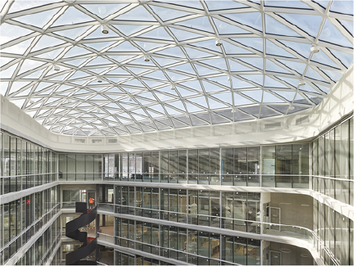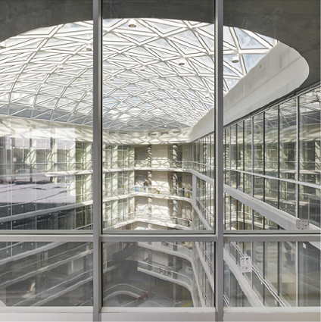
Picture 1 Picture 2
The interior façade of the building is designed to be transparent throughout. A VISS Fire Façade EI30 (50 mm) mullion-transom construction with property-related T-connectors has been used here.

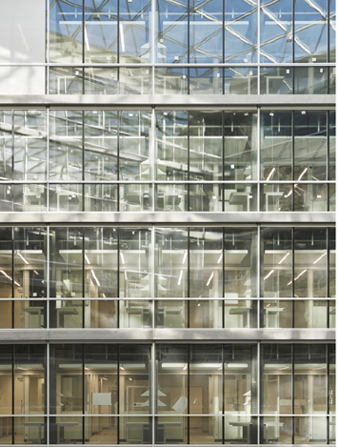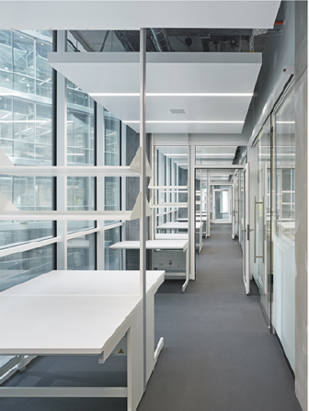
Picture 3 Picture 4
The interior façade is designed as a fire protection façade with regard to the laboratory environment. Boasting various additional components such as fire protection anchors, stainless steel contact profiles etc., the VISS Fire System keeps the panes in the correct position even in the event of a fire.

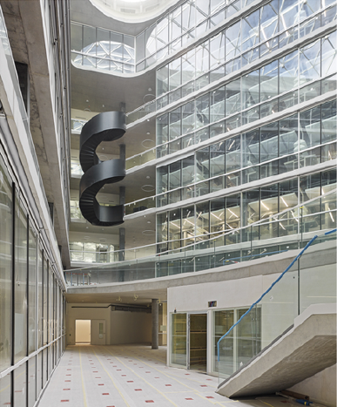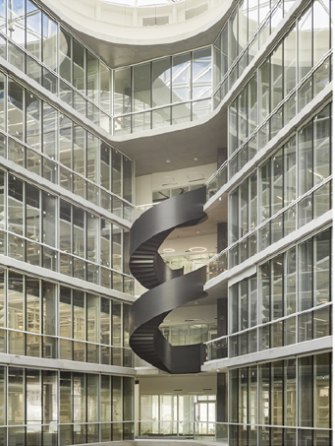
Picture 5 Picture 6
The atrium is the central meeting place and communication point of the higher education institution. It emphasises a distinctive appearance and ensures a high-quality living and working environment.

