Battersea Power Station, London:
Metamorphosis of a coal-fired power station
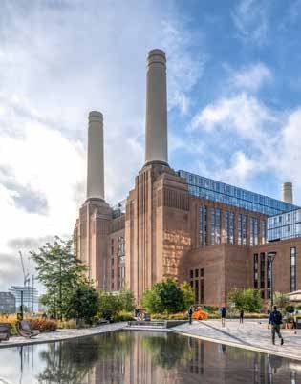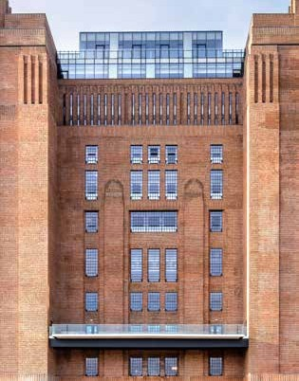

01_BPS © Tim Fisher: The legendary Battersea Power Station has been converted into a mixed-use building designed by the London office of WilkinsonEyre.Architects.
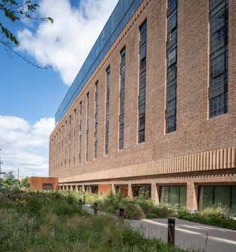
47_BPS © Tim Fisher: Large-scale industrial glazing made of thermally separated steel systems from Jansen increase the incidence of light and ensure contemporary energy standards are met.
38_BPS © Tim Fisher: The carefully considered combination of preservation and renovation measures maintains the charm of the industrial monument for future generations.
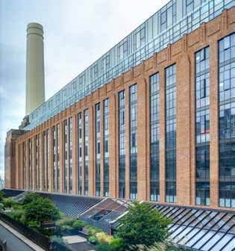
21_BPS © Tim Fisher: With their glass façades, the newly added floors create a clear break from the brick-clad, listed industrial building

Battersea Power Station, London:
Metamorphosis of a coal-fired power station

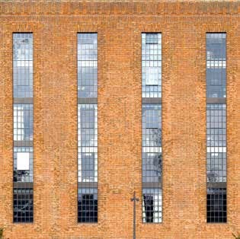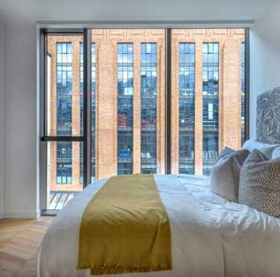

30_BPS © Tim Fisher: To increase the incidence of light inside the building, existing openings were enlarged and infill masonry was replaced by glass constructions.

06_BPS © Tim Fisher: Hundreds of appartements were built in the “switch houses” on both sides of the turbine halls. Here, too, the former purpose as an industrial building is palpable.
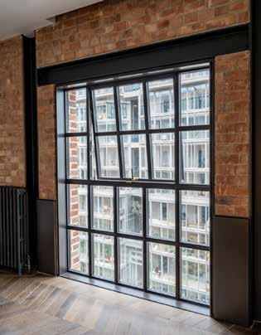
09_BPS © Tim Fisher: Floor-to-ceiling glazing with movable sashes, in this case, as projected top-hung windows enable the residents to open the windows as they wish.

Battersea Power Station, London:
Metamorphosis of a coal-fired power station
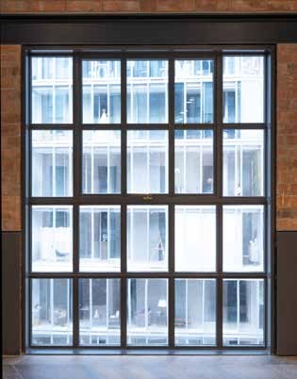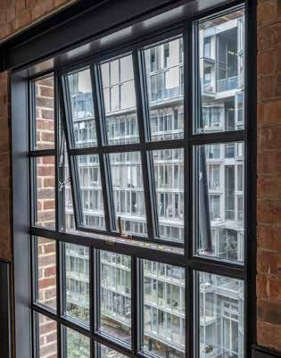

14_BPS © Tim Fisher: With its great variety of opening types – here as projected top-hung windows – Janisol Arte 2.0. is ideally suited to the renovation of historic industrial glazing.
11_BPS © Tim Fisher: The linear operating elements with a brass finish were specially developed by Jansen for the project.

10_BPS © Tim Fisher: The 1 m x 1 m projected top-hung windows can be tilted outwards with a single handle. The
1.10 m x 1.45 m elements are operated with two handles.
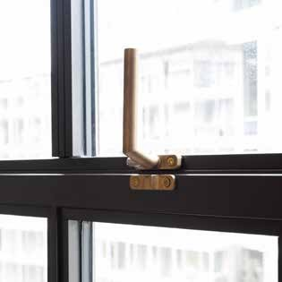
13_BPS © Tim Fisher: To open, the handle is turned upwards by 90 degrees and the projected top-hung window is tilted outwards.

Battersea Power Station, London:
Metamorphosis of a coal-fired power station
Battersea Power Station is the centrepiece of the transformation of a brownfield site into a compact urban quarter. Through a clever combination of preservation and renovation measures, WilkinsonEyre.Architects have maintained the historic charm of the industrial heritage building while at the same time adapting it to today's energy requirements – thanks to Janisol Arte 2.0, among other things: “The steel system enabled us to retain the original proportions while at the same time allowing us to use double-glazed insulating glass,” says Sebastien Ricard, Project Manager at WilkinsonEyre.Architects.

It is one of London's most famous landmarks: Battersea Power Station, a former coal-fired power station on the south bank of the Thames. Designed by Sir Giles Gilbert Scott as a brick-clad steel skeleton structure, construction of the building began in 1929 with the power station being commissioned in 1933. Until the end of the Second World War, Battersea Power Station consisted only of the elongated Block A with two chimneys. After 1945, it was extended by the almost identical Block B. This gave the building its characteristic appearance with the four white chimneys rising 110 metres into the sky.

From industrial wasteland to urban quarter
After the power plant was shut down at the end of the 1980s, there were various projects for redeveloping the 17-hectare industrial wasteland. However, none of these proved conclusive and the site changed hands several times. The current owner is a Malaysian consortium of investors; the transformation into a modern urban quarter is being run by the UK-based Battersea Power Station Development Company. According to its master plan, more than 4,000 apartments, tens of thousands of square metres of office space and a small power station would be built in eight construction phases, each under the leadership of star architects from all over the world.

Second construction phase: Battersea Power Station redevelopment
In 2013, the world-renowned firm WilkinsonEyre.Architects was commissioned to implement the second construction phase, the renovation of the power station protected by listed building status (Grade II, “particularly important buildings of general interest”).
Their designs for the conversion into a mixed-use building respect the characteristic atmosphere, monumentality and spaciousness of the industrial heritage building while at the same time creating contemporary space for urban uses. These include hundreds of new apartments on both sides of the turbine halls as well as a series of exclusive villas around a roof garden above the boiler house. The restored turbine halls offer thousands of square metres of space for retail outlets, restaurants and events on three levels. The former boiler house is mainly home to office space - Apple alone occupies more than 46,000 square metres on all six floors, making it the largest tenant of the architectural icon. One of the four chimneys has been converted into a glazed viewing platform offering a unique panoramic view over London.

Steel – the first choice now as in the past
The new external appearance is underlined by the so-called “heritage windows”, comprising 2,000 window elements made by seele (UK) Ltd, a company in the Gersthofen

seele Group, and based on the historic design from 1930. In dialogue with WilkinsonEyre.Architects, the decision was taken to adopt the thermally separated Janisol Arte 2.0 steel profile system from Jansen: “After exhaustive international research, the Jansen system was found to be the ideal match to replicate the Crittall-style single glazed 1930s/50s windows originally used in the Power Station,“ says Sebastien Ricard, Project Manager at WilkinsonEyre.Architects, adding: “The system allowed us to match the original window frame module and proportions, but permitted the use of double glazed high performance window elements to meet modern energy performance standards. Janisol Arte 2.0 is a slim, elegant system which has proved perfect to use in the highly sensitive context of this famous
and historic listed building.”

Battersea Power Station: The Place To Be
The renovation of Battersea Power Station was largely completed when the residents moved into the “Switch House West” apartments at the end of May 2021. The approximately 1,400 employees of Apple's London branch also moved into their offices in the new Apple Campus in 2021. The building has nevertheless only been open to the general public since 14 October 2022. This means that the coal-fired power station on the banks of the Thames, which was shut down 30 years ago, is looking towards a promising future. The transformation by WilkinsonEyre.Architects once again shows that an historic building fabric, coupled with an innovative architectural concept, creates spaces that not only go down well with locals. With the viewing platform on the north-west chimney, the legendary London landmark should also become a popular location for tourists.

Project details:

Client: Investor consortium consisting of PNB (Malaysian sovereign wealth fund Permodalan Nasional Berhad), Sime Darby Property, S P Setia and the Employees' Provident Fund Project management: Battersea Power Station Development Company, London
Design: WilkinsonEyre.Architects, London Façade design: Buro Happold Ltd, Bath Façade construction: seele Group, Gersthofen
Steel profile system: Jansiol Arte 2.0, VISS Façade, Janisol
Manufacturer: Jansen AG, CH-Oberriet

Photos: Tim Fisher, Heist op den Berg/Belgium
Image rights: Jansen AG, Oberriet, Switzerland
The editorial use of the illustrations is bound to the present property report.
Contact for the editorial offices

BAUtext Media Service Munich Anne Marie Ring
Pernerkreppe 20
DE-81925 Munich
Tel.: +49 (0) 89 12 09 62 77
Email: a.ring@bautext.de www.bautext.de

Jansen AG Anita Lösch
Industriestrasse 34 CH-9463 Oberriet SG
Tel.: +41 (0)71 763 99 31
Email: anita.loesch@jansen.com www.jansen.com

