MEDIA INFORMATION | April 2022
VISS RC4 burglar-resistant façade:
tried-and-tested system solution for increased property protection
What was initially developed as a commercial solution is now available as a tried-and-tested system solution: VISS RC4 is the advanced version of the burglar-resistant VISS façade for enhanced building protection. Resistance classes RC 2, 3 and 4 can be implemented based on the tried-and-tested VISS façade. VISS RC4 enables Jansen, Europe’s leading manufacturer of steel profile systems for to meet the growing need for high security with simple manufacturing and assembly.

VISS RC4 façade also provides protection from even the most well-equipped burglars. The VISS RC4 façade can withstand the standardised break-in attempt in accordance with EN 1630 for at least ten minutes. Experience has shown that even experienced burglars are more likely to give up the longer the break-in attempt lasts, as the risk of being detected increases with every minute that passes.
Visually identical to the standard VISS façade, the burglar resistance measures are perfectly concealed in structures that incorporate VISS RC. The VISS façade can be upgraded to a burglar-resistant structure up to RC4 with just a few additional components. Other requirements can also be implemented while maintaining an unchanged, uniform appearance. For example, the VISS RC4 façade can be easily expanded with insulating cores to create a highly insulated façade. This not only provides a reliable solution, but also meets the growing demand for energy-efficient systems. The VISS RC system solution can be designed with the standard VISS system in face widths of 50 and 60 mm. In addition, thanks to VISS Basic, any type of support profile can be used. Insert elements from Janisol, Janisol Arte and Jansen Economy 50/60 with corresponding RC approval can be integrated. VISS RC4 allows the use of filling element thicknesses of 18 to 70 mm. In terms of the format, the only determining factor is the weight of the filling element.
Façade constructions with VISS RC carry the CE marking in accordance with the EN 13830 product standard and are tested in accordance with standard 1627 for burglary and escape resistance. They also meet the most stringent requirements in terms of heat transmission (coefficient U_{f} > 0.84 W/m²K), tightness against heavy rain (class RE 1200), air permeability (class AE), resistance to wind load (class 2 kN/m²) and impact resistance (class E5/I5).

Digitally supported planning and production
With digital twins of all steel systems, Jansen supports architecture and planning offices from the design phase onwards. The option to virtually combine, visualise and optimise window, door and façade systems offers great potential for cost and time savings within the construction industry. The tried-and-tested JANIsoft software for architecture firms and manufacturing companies makes planning, calculation and construction with Jansen steel profile systems simple and efficient – from planning and job preparation to machine control. The service portfolio also includes testing, calculations and dimensioning. All documents relating to the steel profile systems are available to download free of charge in the Jansen Docu Center. There you will also find the latest versions of the product ranges, processing documents and relevant certificates and verifications that metalworking companies require for performance declarations and CE marking.

Contact person for your readers:
Jansen AG, CH-Oberriet
www.jansen.com

About Jansen AG
Jansen AG was founded in 1923 and is based in Oberriet, Switzerland. The Group develops,
produces and distributes steel profile systems and plastic products for various segments of the building industry. Since 1978, Jansen has been the exclusive Swiss sales partner of the German company Schüco International KG and distributes its aluminium profile systems within the construction sector. In January 2021, Jansen AG acquired the subsidiary RP Technik GmbH, which is also a provider of steel solution systems for façades, windows and doors, from the Welser Profile Group of Companies. Jansen handed over its automotive supply business to Mubea on 1 April 2021. On 1 January 2022, Jansen AG opened an independent Representative Office in Breda (NL) and has been directly responsible for market development in the Netherlands and Belgium ever since. To this day, the Jansen Group is 100% family-owned, employs around 620 people internationally and generates a turnover of CHF 200 million.

Editorial contacts:
Jansen AG
Anita Lösch
Industriestrasse 34
CH-9463 Oberriet SG
Tel.: +41 (0)71 763 96 72
E-mail: anita.loesch@jansen.com

See illustration for image credits
Editorial use of the images is restricted to Jansen and the products mentioned in the text.

Boijmans van Beuningen viewable storage area, Rotterdam: The 1664 mirrors were installed in a VISS SG façade with the RC4 burglar resistance requirement. (Photo: Ossip van Duivenbode/Jansen AG)

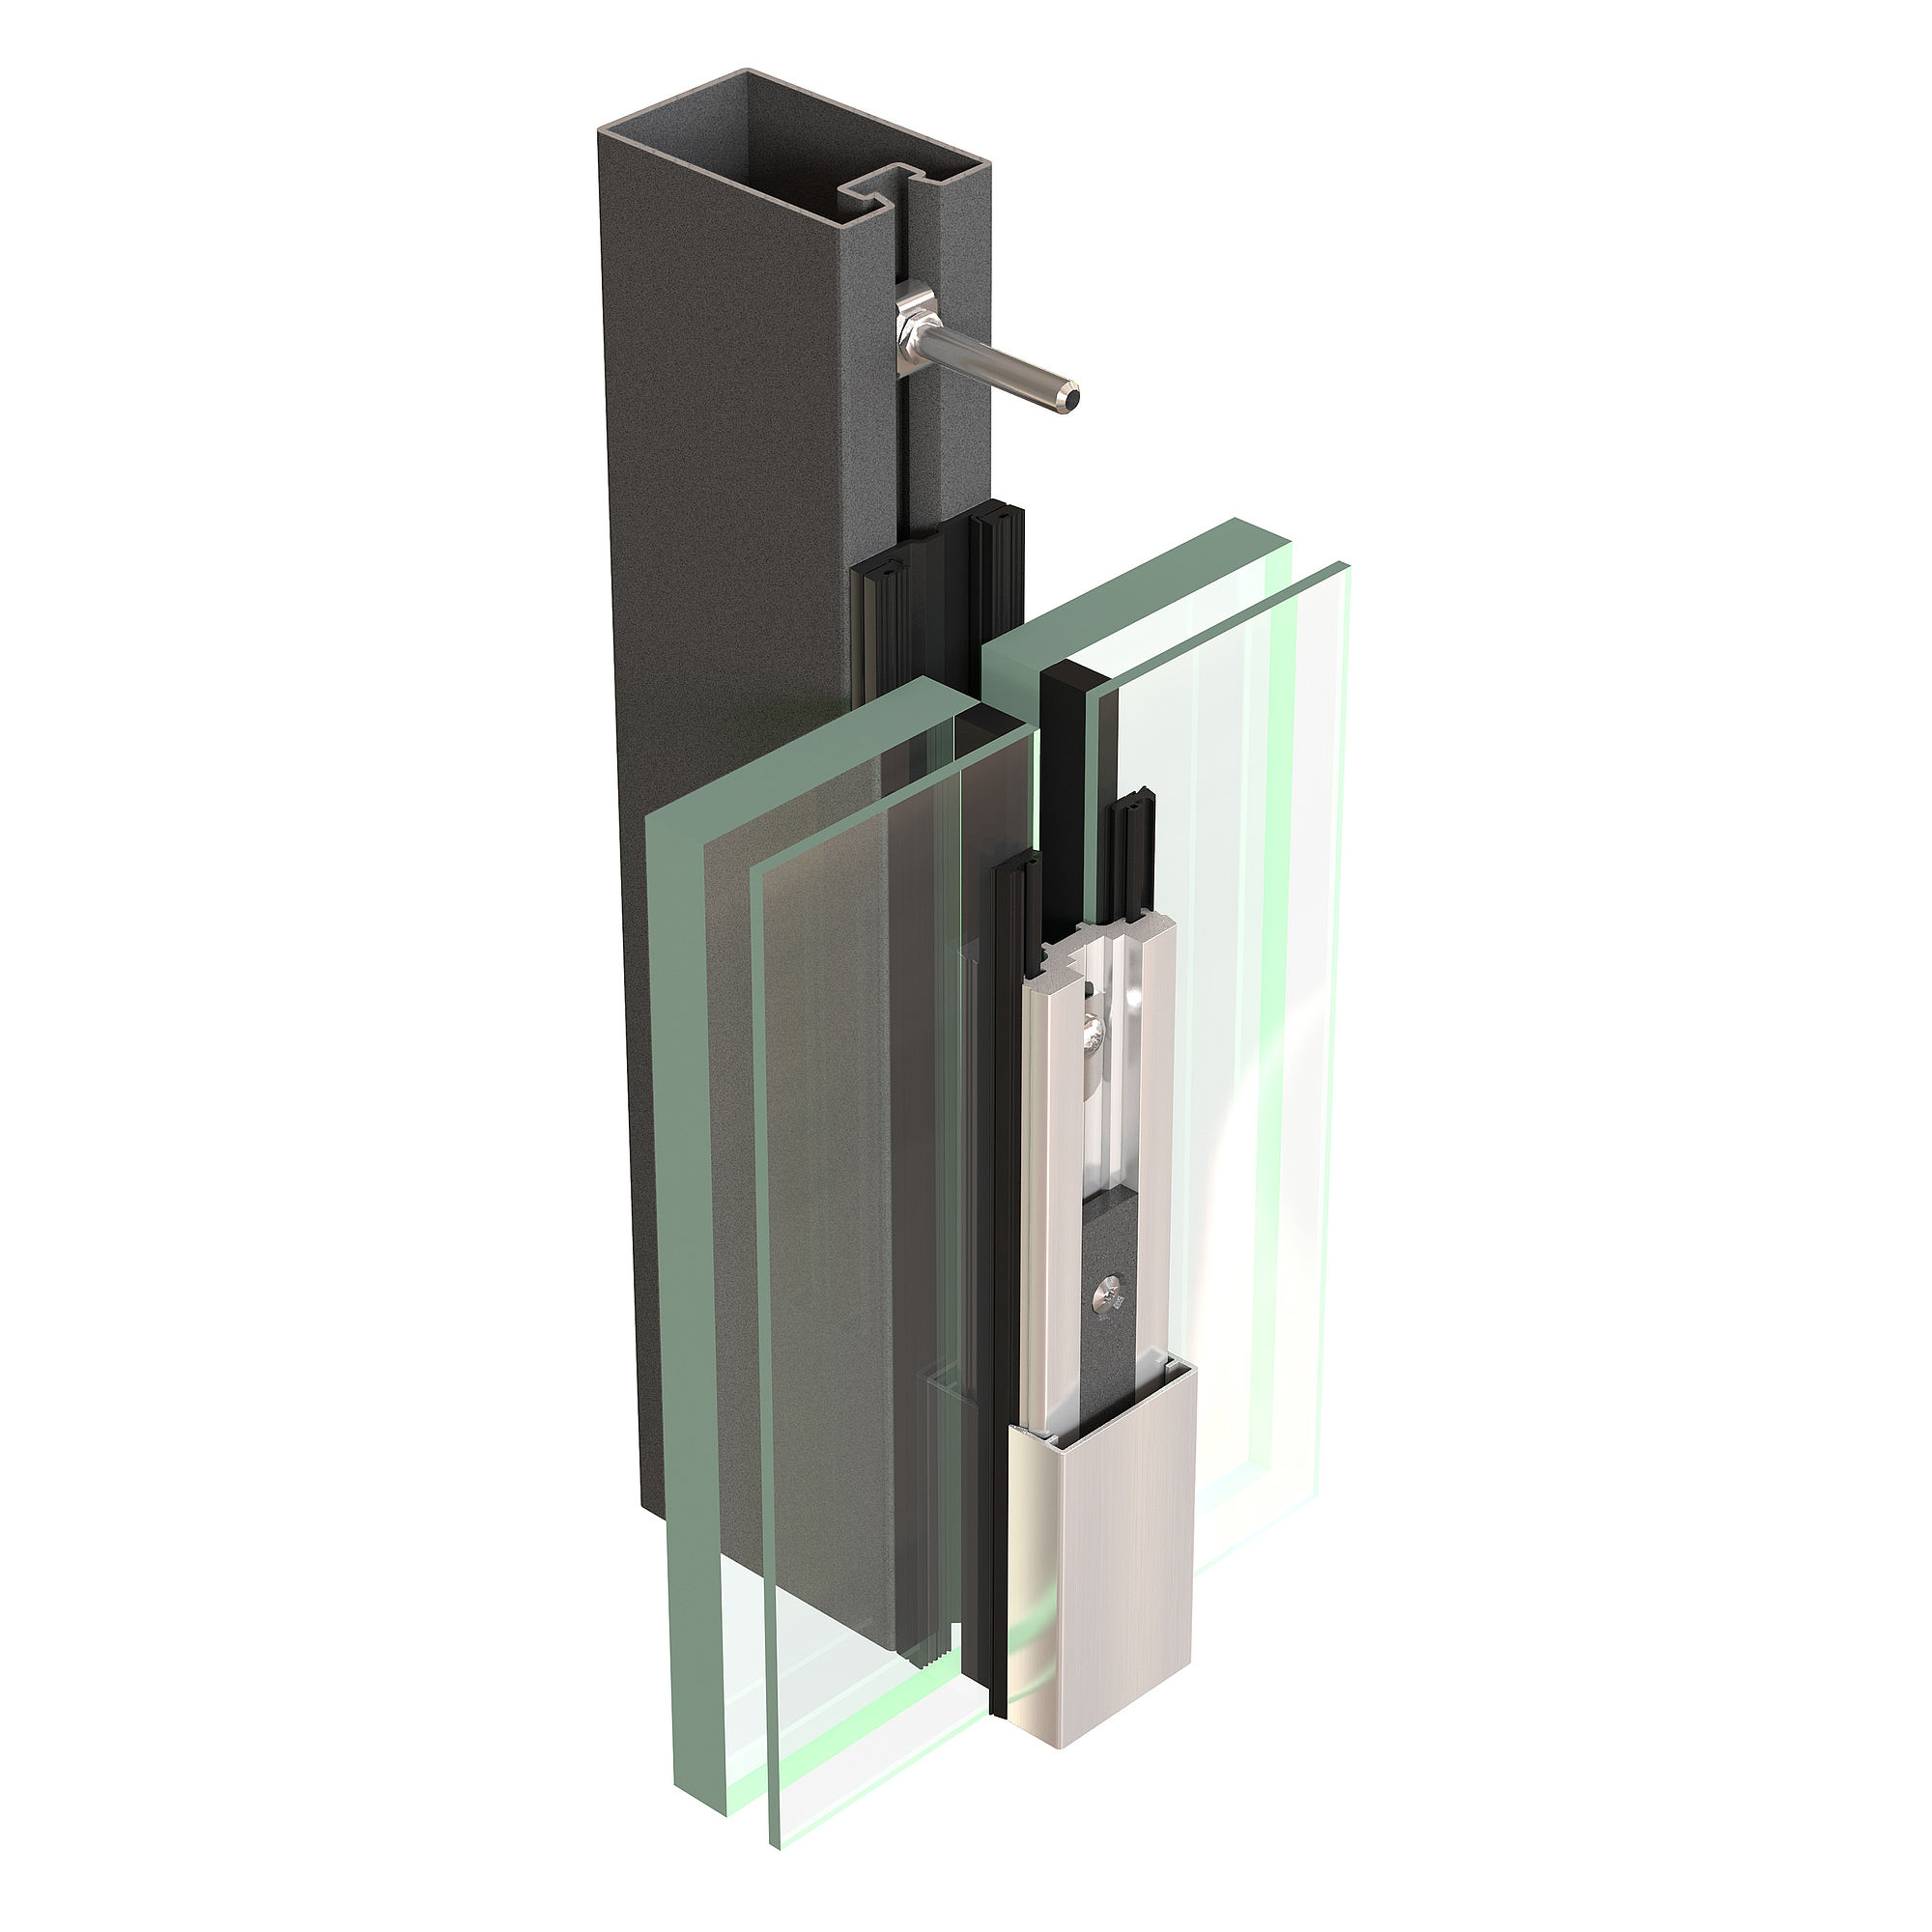

VISS RC4 Rendering.tif: Thanks to the simplified design and the small number of additional components, VISS RC can be quickly and easily installed as a post-post-transom or post-transom-post construction. (Photo credits: Jansen AG)

